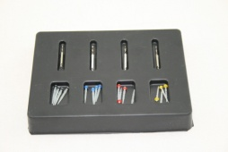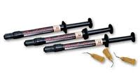

**Fiber Post Kits**

**4 sizes x 5 Posts + 4 Drills**

[**1@$79.92**](mailto:1@$79.92) **3@ $63.90**

**Revolution Syringes**

**4 x 1 Gr. A1, A2, A3**

[**1@$76.50**](mailto:1@$76.50) **5@ $67.50**

CALL US @ 905-669-0092

OR 1-866-805-1219

BS’D

PLACE AN ORDER FOR $350.00 GET $25.00 GIFT CARD VISA OR MASTER CARD

PLACE AN ORDER FOR $500.00 GET $50.00 GIFT CARD VISA OR MASTER CARD

PLACE AN ORDER FOR $1000.00 GET $125.00 GIFT CARD VISA OR MASTER CARD

PLACE AN ORDER FOR $1800.00 GET $200.00 GIFT CARD VISA OR MASTER CARD

**Charisma Syringes**

**A1, A2, A3, A3.5, A4, B1, B2**

[**1@$54.90**](mailto:1@$54.90) **6@ $47.25**

**Tetric Evo Ceram**

**20/Pack A1, A2, A3**

[**1@$117.00**](mailto:1@$117.00) **3@ $108.90**

**$144.90**

**Tetric Evo Flow Syringe**

**A1, A2, A3**

[**1@$56.70**](mailto:1@$56.70) **4@ $53.10**

[**1@$155.60**](mailto:1@$155.60) **3@ $144.90**

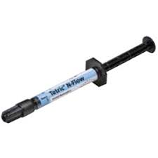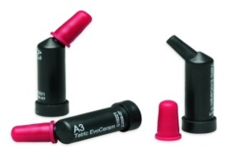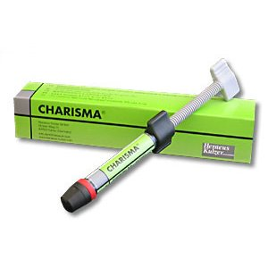

**Genie Light Body**

**STD Set**

[**1@$45.00**](mailto:1@$45.00)  **3@ $40.95**

[**1@$155.60**](mailto:1@$155.60) **3@ $144.90**

**Genie Bite Registration Fast Set**

[**1@$54.00**](mailto:1@$54.00)  **3@ $49.50**

[**1@$155.60**](mailto:1@$155.60) **3@ $144.90**

**K-Files 6/Pack**

**06, 08, 10, 15, 20, 25, 30, 35, 40 or 15-40**

**21mm, 25mm, 30mm**

[**1@$10.80**](mailto:1@$10.80) **10 @ 9.45 ea.**

**20 @ 7.92 ea**

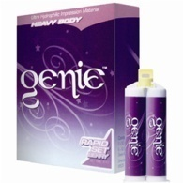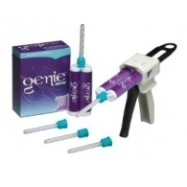

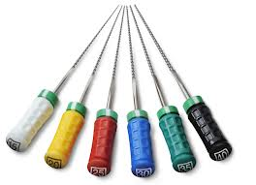

**Etch Rite Refill**

**2 x 25 gr. Syr. (Pulpdent)**

[**1@$67.50**](mailto:1@$67.50) **3@ $61.20**

[**1@$155.60**](mailto:1@$155.60) **3@ $144.90**

**Light Curing Unit**

**B-Type Complete Kit**

[**1@$270.00**](mailto:1@$270.00) **2@ $234.00**

[**1@$155.60**](mailto:1@$155.60) **3@ $144.90**

**JOY Etch Refill**

**50 gr. Syr. (3D Dental)**

[**1@$45.90**](mailto:1@$45.90) **3@ $39.96**

[**1@$155.60**](mailto:1@$155.60) **3@ $144.90**

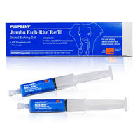

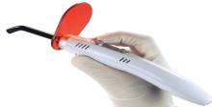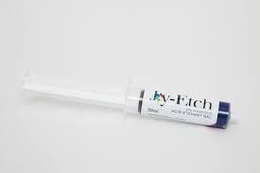



**canadawidedental@rogers.com**

**905-660-4494**

**905-669-0092**

**1-866-805-1219**

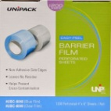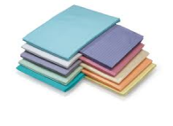

**Gauze Sponges**

**2 x 2 5000/Box 1@ $46.80**

**3@ $42.30**

**4 x 4 2000/Box 1@ $56.70**

**3@ $52.20**

[**1@$67.50**](mailto:1@$67.50) **3@ $62.10**

[**1@$155.60**](mailto:1@$155.60) **3@ $144.90**

**Barrier Film**

**Blue or Clear 1200/Roll**

[**1@$23.40**](mailto:1@$23.40) **3@ $20.70**

[**1@$155.60**](mailto:1@$155.60) **3@ $144.90**

**Bibs 500/Box**

**3 Ply – Blue or Lavender**

[**1@$33.30**](mailto:1@$33.30) **2@ $29.97**

[**1@$155.60**](mailto:1@$155.60) **3@ $144.90**

**Gloves Nitrile**

**Powder Free 300/Box XS, S, M**

[**1@$29.97**](mailto:1@$29.97) **5@ $26.55**

[**1@$155.60**](mailto:1@$155.60) **3@ $144.90**

**Saliva Ejectors**

**1000/Box Clear Blue or White**

[**1@$39.96**](mailto:1@$39.96) **2@ $34.20**

[**1@$155.60**](mailto:1@$155.60) **3@ $144.90**

**Cups Plastic 5 oz.**

**1000/Box Blue or Lavender**

[**1@$36.00**](mailto:1@$36.00) **2@ $31.95**

[**1@$155.60**](mailto:1@$155.60) **3@ $144.90**

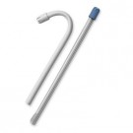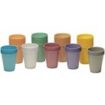

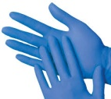

**Surgi Vac Tips**

**25/Pack Green, White, Blue**

[**1@$16.20**](mailto:1@$16.20) **3@ $13.50**

[**1@$155.60**](mailto:1@$155.60) **3@ $144.90**

**Head Rest Covers**

**NON WOVEN 500/Box 10 x 13**

[**1@$49.95**](mailto:1@$49.95) **2@ $46.80**

[**1@$155.60**](mailto:1@$155.60) **3@ $144.90**

**Sterilization Pouches 200/Box**

**2.5” x 4** [**1@$7.92**](mailto:1@$7.92) **6@ $7.20**

**2.1/4” x 9** [**1@$8.55**](mailto:1@$8.55) **6@ $7.38**

**3.5” X 5 1/4** [**1@$8.55**](mailto:1@$8.55) **6@ $7.38**

**3.5” x 10** [**1@$10.80**](mailto:1@$10.80) **6@ $9.90**

**5.5” x 7.5** [**1@$11.70**](mailto:1@$11.70) **6@ $10.35**

**5 ¼” X 11** [**1@$19.98**](mailto:1@$19.98) **6@ $17.91**

[**1@$155.60**](mailto:1@$155.60) **3@ $144.90**

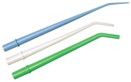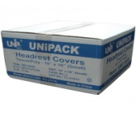

**Tray Covers Ritter**

**8 3/8” x 11 - 1000/Box**

[**1@$24.30**](mailto:1@$24.30) **3@ $21.96**

[**1@$155.60**](mailto:1@$155.60) **3@ $144.90**

**Earloop Masks**

**50/Box Generic Blue**

[**1@$14.40**](mailto:1@$14.40) **10@ $9.90**

[**1@$155.60**](mailto:1@$155.60) **3@ $144.90**

**Microbrushes Generic**

**400/Box Fine, Reg, Superfine**

[**1@$27.90**](mailto:1@$27.90) **3@ $24.30**

[**1@$155.60**](mailto:1@$155.60) **3@ $144.90**

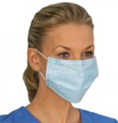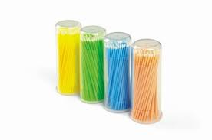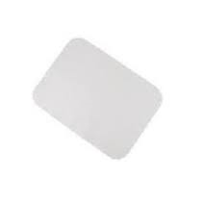

**Blades**

**#15 or #12 100/BOX**

[**1@$24.30**](mailto:1@$24.30) **2@ $22.50**

[**1@$155.60**](mailto:1@$155.60) **3@ $144.90**

**Prophy Cups Dentamerica 144/Box**

**Snap-On** [**1@$15.93**](mailto:1@$15.93) **3@ $13.50**

**Screw-On** [**1@$28.80**](mailto:1@$28.80) **3@$25.20**

**R.A. Latch** [**1@$37.80**](mailto:1@$37.80) **3@ $35.10**

[**1@$155.60**](mailto:1@$155.60) **3@ $144.90**

**Ultrasonic Tablets**

**64/Box**

[**1@$40.95**](mailto:1@$40.95) **2@ $37.80**

[**1@$155.60**](mailto:1@$155.60) **3@ $144.90**

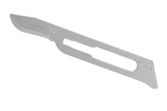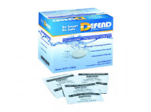

**Cavi Wipes**

**Large Can 12/Case**

[**1@$16.20**](mailto:1@$16.20) **12@ $15.30**

[**1@$155.60**](mailto:1@$155.60) **3@ $144.90**

**Gutta Percha**

**Points All Sizes 120/Box**

[**1@$9.90**](mailto:1@$9.90) **5@ $8.37**

[**1@$155.60**](mailto:1@$155.60) **3@ $144.90**

**Absorbent Paper**

**Points All Sizes 100/Box**

[**5@$9.90**](mailto:5@$9.90) **5@ $7.92**

[**1@$155.60**](mailto:1@$155.60) **3@ $144.90**

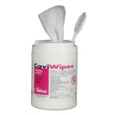

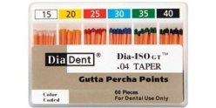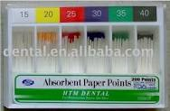

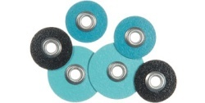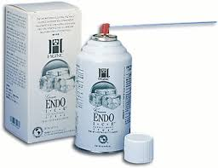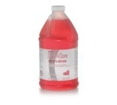

**Soflex Discs 85/PK**

**1981, 1982, 2381, 2382 SF, F, M, C**

[**1@$45.90**](mailto:1@$45.90) **5@ $41.40**

[**1@$155.60**](mailto:1@$155.60) **3@ $144.90**

**Endo Ice Spray**

**500 ML**

[**1@$39.60**](mailto:1@$39.60) **3@ $36.45**

[**1@$155.60**](mailto:1@$155.60) **3@ $144.90**

**Flouride Rinse Mint**

**1.9 L Bottle with Pump**

[**1@$45.90**](mailto:1@$45.90) **3@ $41.40**

[**1@$155.60**](mailto:1@$155.60) **3@ $144.90**

**Stabilok Pins**

**Yellow, Green, Blue, Orange**

[**1@$162.90**](mailto:1@$162.90) **3@ $156.96**

[**1@$155.60**](mailto:1@$155.60) **3@ $144.90**

**Soflex 1983 Mandrels**

**3/Pack**

[**1@$45.00**](mailto:1@$45.00) **3@ $39.60**

[**1@$155.60**](mailto:1@$155.60) **3@ $144.90**

**Gluma Desensitizer**

**5 ML Bottle**

[**1@$94.50**](mailto:1@$94.50) **3@ $85.50**

[**1@$155.60**](mailto:1@$155.60) **3@ $144.90**

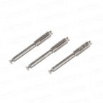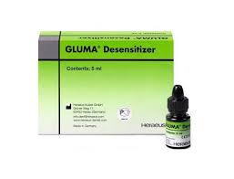

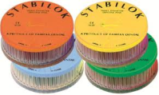

**Kodak DF-54 Film**

**#0 100/Pack**

[**1@$63.00**](mailto:1@$63.00) **4@ $58.95**

[**1@$155.60**](mailto:1@$155.60) **3@ $144.90**

**Kodak DF-58 Film**

**#2 150/Pack**

[**1@$69.30**](mailto:1@$69.30) **6@ $65.70**

[**1@$155.60**](mailto:1@$155.60) **3@ $144.90**

**Sutures 3/0 or 4/0**

**Gut, Chromic Gut, Silk 12/Pk**

[**1@$43.20**](mailto:1@$43.20) **3@ $39.60**

[**1@$155.60**](mailto:1@$155.60) **3@ $144.90**

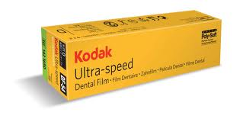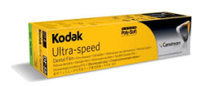

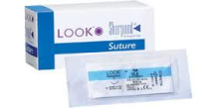

**High Speed Surgical**

**4 Hole Hand Piece Being Equip**

[**1@$239.50**](mailto:1@$239.50) **2@ $199.98**

[**1@$155.60**](mailto:1@$155.60) **3@ $144.90**

**Kodak TMG - 5**

**5 X 12 50/Pack**

[**1@$139.95**](mailto:1@$139.95) **3@ $135.00**

[**1@$155.60**](mailto:1@$155.60) **3@ $144.90**

**Kodak IP-21 Film**

**#2 Film 150/Pack**

[**1@$79.92**](mailto:1@$79.92) **4@ $73.98**

[**1@$155.60**](mailto:1@$155.60) **3@ $144.90**

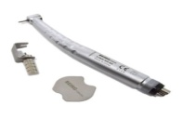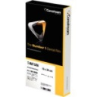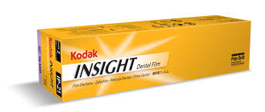

**Mouth Mirrors**

**Cone socket #4 or #5 12/Box**

[**1@$38.70**](mailto:1@$38.70) **2@ $35.10**

[**1@$155.60**](mailto:1@$155.60) **3@ $144.90**

**Dream Prophy Paste**

**200/Cups Mint, Cherry Coarse**

[**1@$45.00**](mailto:1@$45.00)  **3@ $36.90**

[**1@$155.60**](mailto:1@$155.60) **3@ $144.90**

**XRV Unidose Enamel**

**20/Box All Shades**

[**1@$68.40**](mailto:1@$68.40) **10@ $56.70**

[**1@$155.60**](mailto:1@$155.60) **3@ $144.90**

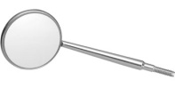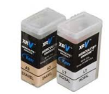

**Air Water Syringe Tips**

**Rainbow 250/Pack**

[**1@$45.00**](mailto:1@$45.00) **4@ $39.96**

[**1@$155.60**](mailto:1@$155.60) **3@ $144.90**

**Spongostan**

**J & J 24/Pack**

[**1@$69.93**](mailto:1@$69.93) **2@ $66.60**

[**1@$155.60**](mailto:1@$155.60) **3@ $144.90**

**Clearfill SE Bond**

**Complete Kit**

[**1@$169.20**](mailto:1@$169.20) **2@ $162.90**

[**1@$155.60**](mailto:1@$155.60) **3@ $144.90**

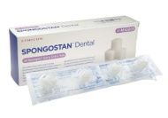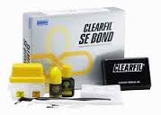

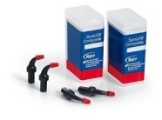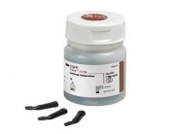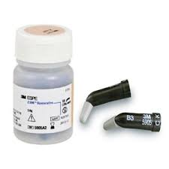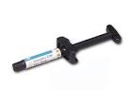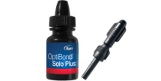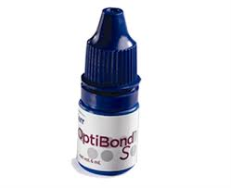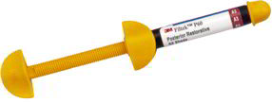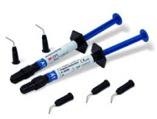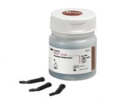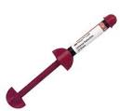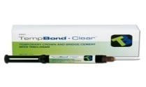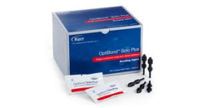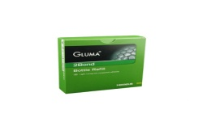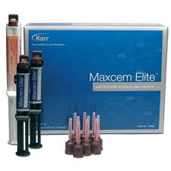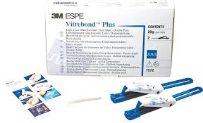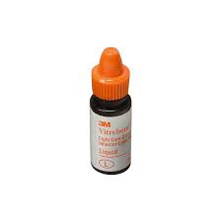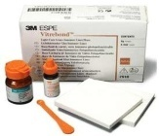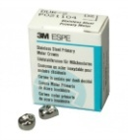

**P-60 Syringe**

**A3 or B2 (3M ESPE)**

[**1@$67.50**](mailto:1@$67.50)  **5@ $59.94**

[**1@$155.60**](mailto:1@$155.60) **3@ $144.90**

**Z-250 Compules US PK**

**20/Box A1,A2,A3,A3.5**

[**1@$135.00**](mailto:1@$135.00) **6 @ $104.40**

[**1@$155.60**](mailto:1@$155.60) **3@ $144.90**

**Optibond Solo Plus**

**5 ML Bottle US PKG**

[**1@$119.70**](mailto:1@$119.70) **4 @ $99.90**

[**1@$155.60**](mailto:1@$155.60) **3@ $144.90**

**Z-100 Compules**

**18/Box A1,A2,A3.A3.5,B1**

[**1@$108.90**](mailto:1@$108.90) **6@ $97.20**

[**1@$155.60**](mailto:1@$155.60) **3@ $144.90**

**Z-250 Compules XT**

**20/Box A1,A2,A3,A3.5**

[**1@$85.50**](mailto:1@$85.50) **4@ $76.50**

[**1@$155.60**](mailto:1@$155.60) **3@ $144.90**

**TempBond Syringe**

**Clear with Triclosan**

[**1@$69.93**](mailto:1@$69.93) **3@ $64.80**

[**1@$155.60**](mailto:1@$155.60) **3@ $144.90**

**Filtek Flow Ultimate**

**A1, A2, A3, A3.5 2 X 2G. Syr.**

[**1@$109.98**](mailto:1@$109.98) **4@ $99.00**

[**1@$155.60**](mailto:1@$155.60) **3@ $144.90**

**Optibond Solo Unidose**

**100/Box**

[**1@$288.00**](mailto:1@$288.00) **2@ $243.00**

[**1@$155.60**](mailto:1@$155.60) **3@ $144.90**

**Gluma 2**

**Bond & Desensitizer 5ML**

[**1@$109.98**](mailto:1@$109.98)  **3@ $98.10**

[**1@$155.60**](mailto:1@$155.60) **3@ $144.90**

**Maxcem Elite**

**Clear or White**

[**1@$108.00**](mailto:1@$108.00) **3@ $99.90**

[**1@$155.60**](mailto:1@$155.60) **3@ $144.90**

**Z-100 Syringe**

**All Shades A1,A2,A3,A3.5 A4**

[**1@$54.90**](mailto:1@$54.90) **6@ $45.90**

[**1@$155.60**](mailto:1@$155.60) **3@ $144.90**

**Z-250 Syringe US PK**

**A1, A2, A3, A3.5, B1, B2**

[**1@$79.20**](mailto:1@$79.20) **6 @ $73.98**

[**1@$155.60**](mailto:1@$155.60) **3@ $144.90**

**SonicFill Unidose**

**A1, A2,A3, A3.5**

[**1@$135.90**](mailto:1@$135.90) **5 @ $130.95**

[**1@$155.60**](mailto:1@$155.60) **3@ $144.90**

**Optibond Solo Plus**

**6 ML Bottle**

[**1@$89.10**](mailto:1@$89.10)  **3@ $82.80**

[**1@$155.60**](mailto:1@$155.60) **3@ $144.90**

**Vitrebond Plus**

**2 x 11gr. Clicker**

[**1@$269.91**](mailto:1@$269.91)  **2 @ $252.00**

[**1@$155.60**](mailto:1@$155.60) **3@ $144.90**

**Vitrebond Liquid Only**

**5.5 ML Bottle**

[**1@$78.30**](mailto:1@$78.30)  **2@ $72.90**

[**1@$155.60**](mailto:1@$155.60) **3@ $144.90**

**Vitrebond P&L Kit**

**3M ESPE**

[**1@$126.00**](mailto:1@$126.00) **3@ $109.98**

[**1@$155.60**](mailto:1@$155.60) **3@ $144.90**

**Ion Nichro Crowns 3M**

**5/Box Blue Stainless All Sizes**

[**1@$49.50**](mailto:1@$49.50) **10@ $45.00 20 @ 39.96**

[**1@$155.60**](mailto:1@$155.60) **3@ $144.90**